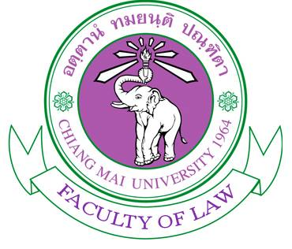

Photo

Application form
CMU-UNE Visiting Student Scholarship 2018

Name : ……………………………………………………………………………………………............. Nickname: ………………………..……...
Student ID: ………………………………………….. Year of Study: …………………………….. Accumulated GPA: ...……………..….
Gender: ……………………………….. Date of Birth: ………………………………………………… Age: ……………………..……………….
Email: ……………………………………………………………………………..……….. Mobile Phone : …………………………..…………….…
Facebook: ………………………………………………………………………….…….. Line ID: ………..………………………………………………
English Language Proficiency: [__] CMU-eTegs Score: ………..……. [__] Other Score: ……….……….
Other Language Proficiency Test: ……………………………………………………………………………………………………….…………..
Why do you want to participate in this program?
…………………………………………………………………………………………………………………………………………..………………………………………………………………………………………………………………………………………………………………………….………………………………………………………………………………………………………………………………………………………………………….………………………………………………………………………………………………………………………………………………………………………….………………………………………………………………………………………………………………………………………………………………………….………………………………………………………………………………………………………………………………………………………….……………………………………………
Why do you think you are suitable to join this program?
…………………………………………………………………………………………………………………………….………………………………………………………………………………………………………………………………………………………………………………………….…………………….……………………………………………………………………………….………………………………………………………………………………………….………………………………………………………………………………………………………………………………………………………………………….…………………………………………………………………………………………………………………………………………………………………………
Applicant’s signature:

……………………………………………………….
Date……………..………………………………..

Remarks:
Applicants are required to submit relevant documents as follow:
- A Complete application form with attached photo
- Résumé (1-2 pages)
- A copy of your updated transcript
- A copy of your language proficiency test result

*** Application Deadline: 15 January 2018 at 16.30 ***
Application submitted later than this dated and time will not be considered.
Please submit the form to P’Poysian (International Relations Officer), 1st fl. Faculty of Law, CMU

