TITLE (14pt Times New Roman, Capital, Bold, Centred)
Margins 3.0 cm
Margins 2.5 cm
Margins 2.0 cm
Leave one blank
*Author’s name (Initial capital, 11pt Times New Roman, Centred)
Leave one blank

*Author’s name (Initial capital, 11pt Times New Roman, Centred)
Leave two blanks

ABSTRACT (Capital, 11pt Times New Roman, Italics, Bold, Centred)
Leave one blank

Single space, 11pt Times New Roman, Italics, Justified-aligned, Indented both left and right by 1.0 cm (or 10 space). ………….…………………………………………………..............
Leave one blank
Keywords: max. 5 words (Single space, 11pt Times New Roman, Italics)
Leave two blanks

INTRODUCTION (Capital, 11pt Times New Roman, Bold)
Leave one blank

Single space, 11pt Times New Roman, Justified-aligned, Space before each paragraph 6pt. …………..
………………………………………………………………………………………………..…………...…………...................................................................................................................................................
Space before paragraph 6pt, Single space, 11pt Times New Roman, Justified-aligned …………………
…………………………………………………………………………………………………………………………………………………………………………………………………………………………
Leave two blanks

I. SECTION (Capital, 11pt Times New Roman, Bold)
Leave one blank

……………………………………………………………………………….………...………………………………………………………………………………………………………………………………
Leave two blanks

II. SECTION (Capital, 11pt Times New Roman, Bold)
Leave one blank

……………………………………………………………………………………………………………........………………………………………………………………………………………………………
Leave one blank

A. Subsection (11pt Times New Roman, Bold, Indented by 1.0 cm.)
Leave one blank
…………………………………………………………………………………………………………………………………………………………………………………………………………………………
Leave one blank
1. Subsection (11pt Times New Roman, Bold, Indented by 2.0 cm.)
Leave one blank
……………………………………………………………………………………………………………
Leave two blanks

CONCLUSION (Capital, 11pt Times New Roman, Bold)
Leave one blank

……………………………………………………………………………………………………………………………………………………………………………………………………….………...………

Margins 2.5 cm
REFERENCES (Capital, 11pt Times New Roman, Bold)

Single space, 10pt Times New Roman, ……...............................................................................................................
A Roman alphabetically-ordered reference list should be included at the end of the manuscript. Several references by the same author(s) should be ordered chronologically (earliest date first). Type each entry using a hanging-indent format
Citations, references, and sources should be fully set out in footnotes to the text and must appear in the reference list. Citations should conform to the Oxford University Standard for Citation of Legal Authorities (OSCOLA), 4th edition 2012, Hart Publishers. Authors are responsible for the accuracy and completeness of all information in a reference.
For more information, please kindly visit “Instruction for authors” at our website:
https://www.tci-thaijo.org/index.php/AJLS/index
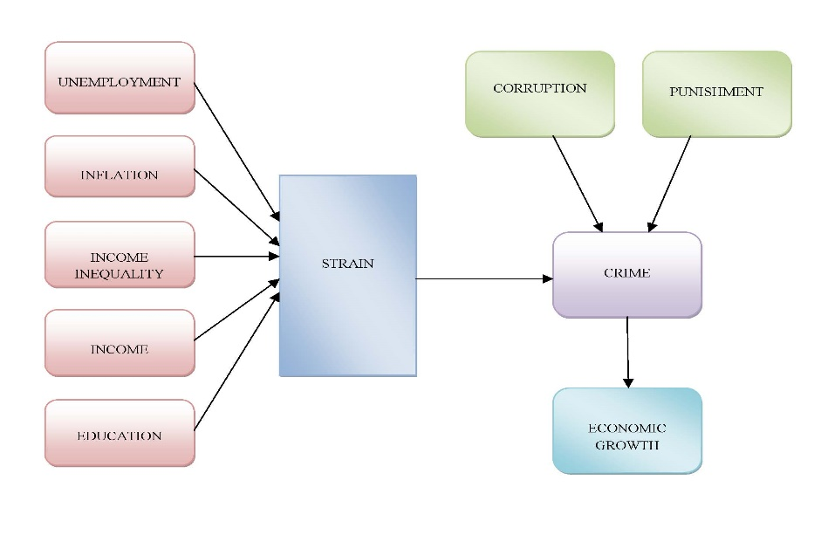
FIGURE 1. Interrelation between Socio and Macroeconomic Variables and Crime

TABLE 1. Pearson Correlation matrix among variables
 |  | Encouragement | Competency | Governance
 | Readiness | 0.0123 | 0.550 | 0.610
 | Competency |  | 1.000 | 0.058
 | Governance |  |  | 1.000

*Source : N/A

