TITLE (14pt Times New Roman, Capital, Bold, Centred)
Leave one blank
Margins 2.0 cm
Margins 2.5 cm
Margins 1.8 cm
Margins 2.0 cm

*Author’s name (Initial capital, 11pt Times New Roman, Centred)
Leave one blank

*Author’s name (Initial capital, 11pt Times New Roman, Centred)
Leave two blanks

ABSTRACT (Capital, 11pt Times New Roman, Italics, Bold)
Leave one blank

Single space, 11pt Times New Roman, Italics, Justified-aligned, Indented both left and right by 1.0 cm (or 10 space).
Leave one blank

Keywords: max. 5 words
Leave two blanks

INTRODUCTION (Capital, 11pt Times New Roman, Bold)
Leave one blank

Single space, 11pt Times New Roman, Justified-aligned, Space before each paragraph 6pt.
Leave two blanks

I. SECTION (Capital, 11pt Times New Roman, Bold)
Leave one blank

……………………………………………………………………………………………
Leave two blanks

II. SECTION (Capital, 11pt Times New Roman, Bold)
Leave one blank

……………………………………………………………………………………………
Leave one blank

A. Subsection (11pt Times New Roman, Bold, Indented by 1.0 cm.)
Leave one blank
……………………………………………………………………………………………
Leave one blank

1. Subsection (11pt Times New Roman, Bold, Indented by 2.0 cm.)
Leave one blank
……………………………………………………………………………………
Leave two blanks

CONCLUSION (Capital, 11pt Times New Roman, Bold)
Leave one blank

……………………………………………………………………………………
Margins 2.5 cm

REFERENCES (Capital, 11pt Times New Roman, Bold, Centred)

REFERENCE LIST
- A Roman alphabetically-ordered reference list should be included at the end of the manuscript.
- Several references by the same author(s) should be ordered chronologically (earliest date first). Multiple references to works by an identical author(s) with the same publication date should be arranged alphabetically by the title that follows the date (excluding A or The) and differentiated by adding lowercase letters (a, b, c, etc.) immediately after the year. For periodicals, include an issue number only if the pages of the periodical are not numbered consecutively throughout the volume (i.e., if each issue begins with page 1)
- Type each entry using a hanging-indent format

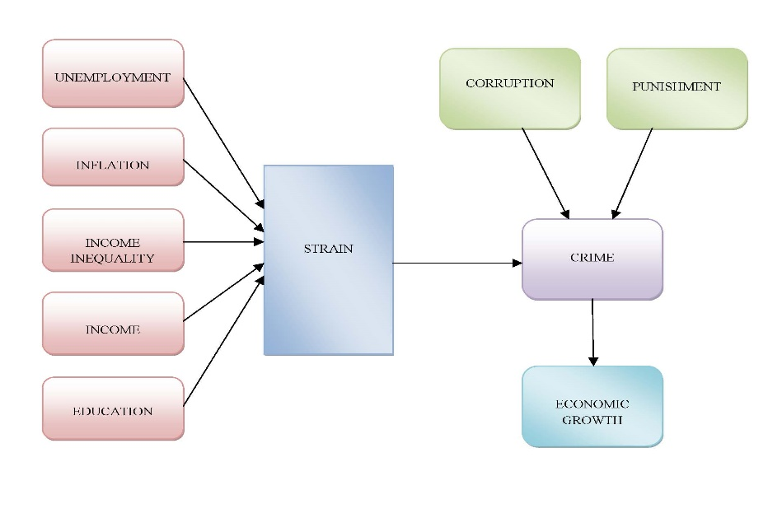
FIGURE 1. Interrelation between Socio and Macroeconomic Variables and Crime

TABLE 1. Pearson Correlation matrix among variables
 |  | Encouragement | Competency | Governance
 | Readiness | 0.0123 | 0.550 | 0.610
 | Competency |  | 1.000 | 0.058
 | Governance |  |  | 1.000

*Source : N/A

